RESEARCH & STRATEGY

Contact Telephone No. 7683 1332 OCTOBER 2001

ECONOMIC SUMMARY FOR SEPTEMBER 2001

Impact of the War on Terrorism

The shock of the 11 September attack on New York and Washington has caused people in the US to stop spending, especially in areas where they feel vulnerable. People respond to crises by keeping their options open and the best way to do this is to hold cash. Because of the perceived danger, people are not traveling. Airlines have cut the number of flights and orders for new planes. Some airline companies, which were already in trouble, eg. Swiss Air and Sabena, face bankruptcy. This has meant that airports, hotels, tourist attractions and aerospace industries have started to shed labour. These cutbacks rebound across the economy. Companies facing uncertainty hedge their bets by postponing investment decisions.

The cost of paying out for damage will be over $100bn, so all insurance premiums are likely to rise. Risk analysis will lead to a significant upward variation in premiums. The airlines, and occupiers of tall buildings, have to face higher insurance premiums. Increased security will add to costs in all areas exposed to attack. Terrorism is like a tax on economic activity.

The stock market is a barometer of confidence and the charts show that, whilst confidence is at a low ebb, there is no catastrophic collapse of confidence. In the interlude between the attack and the response, uncertainty has been the chief economic worry. The main concern is "where will the next target will be?". "Hedging bets" means not spending or investing. Cash reserves build up, waiting for a more certain outlook.
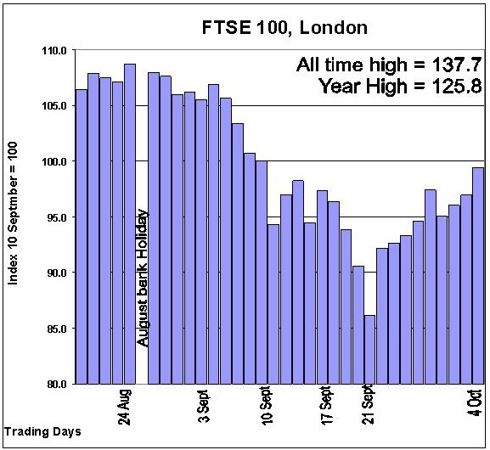
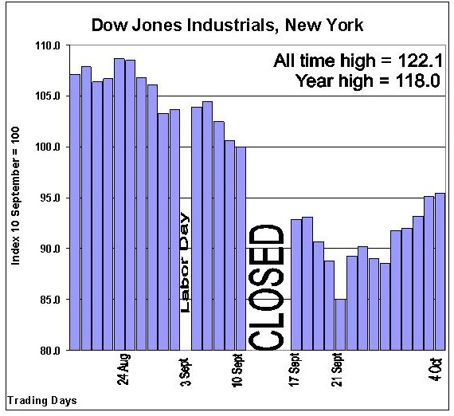

For the period after the attack to 21 September, the US and UK stock markets fell by 15%. They have recovered by about 5-7% since their low point, however, uncertainty still haunts the markets keeping them from recovering fully. This means that the performance of many pension funds and endowment policies will falter and explains the recent concern in the insurance industry at the general fall-off in share price. The attack caused confidence and share prices to drop but not collapse.

After a while, the cash reserves will have been built up to levels where people feel able to cope with whatever happens. Spending begins to recover and investment levels follow. In order to stimulate spending, interest rates are cut. This raises liquidity in the markets and helps reassure people that the uncertainty is manageable. US interest rates, following the latest 0.5% cut to 2.5%, are now the lowest for forty years. This reflects the slowing down of the US economy and the terrorist attack. The 0.25% cut in the UK reflects its stronger economic position but, even so, share prices rose, on 4 October, to almost pre-attack levels, whilst New York was still 5% below.

This is what is happening in the USA and, to a lesser extent, in the UK and the rest of the EU. The Far East, already suffering from the electronics shakeout, has been hard hit. The economic downward pressure comes at a time when the USA was heading for zero growth. The UK is in a much stronger position with second quarter growth at 2.3%. If the post-attack shock continues, the US will enter a recession and the UK could have 1% knocked off the growth rate; world trade is likely to fall.

Coventry Economic News During September

It is far too early to assess any impact of the attack on the local economy. Tourism is down, especially following the postponement of the Ryder Cup. Hotel bookings are reported to be down. Inward investment enquiries fell away the week following the attack, but have now recovered. Consumer spending levels are reported to be down, some shops have reported falling turnover whilst others see little change.

Manufacturing in Britain is officially in recession with output falling over the last few months. The US slowdown and post-attack shock is hurting exports, hence Jaguar workers are having a two week paid break to prevent the build-up of stocks. Lotus is closing its Coventry plant, with 35 job losses, reflecting market conditions for luxury cars. It has been the electronics sector that has led the downturn with output some 20% down from last September. Marconi has not yet managed to persuade its detractors that it has "turned the corner". Its share prices are still new record lows.

Whilst the autumn is bringing some bad economic news, investment is still taking place locally and new jobs are in the pipeline. Local forecasts indicate that service sector employment will continue to expand over the next 12 months. Lexus created 20 new jobs in a £1.2m showroom when it relocated to London Road from Solihull. Insurance Line has taken a floor in Tower Court, Foleshill Enterprise Park, which is likely to create more jobs. The Radford Arms site is to be redeveloped and KFC and Dominos Pizzas have already taken up space on the site. Frank and Benny's is to open an Italo-American Restaurant and Bar in Coventry.

Construction work is well advanced on the Adult Learning Inspectorate Building on the Coventry Business Park. Another large unit is being developed at the Pro Logis Business Park with new office space now ready for letting on the Central Boulevard. The big question is "will the 10,000m² Makro warehouse be completed in time for it to open by Christmas?" (less than six months from start to finish).

The Coventry Evening Telegraph Business Awards Scheme is asking for nominations for twelve prizes. The awards cover small business, entrepreneurs, young people, customer care, innovation, training excellence, export achievement, etc. The City Council sponsors the business contribution to the community award.

JOB VACANCIES IN COVENTRY

The official statistics have been erratic since the new recording system was introduced. In July 2001, the last month for which data was published, there were 1,314 vacancies (4 unemployed people for every vacancy). The vacancies reported in Thursday's Evening Telegraph remain at relatively high levels and suggest that recruitment is still strong, although below the peak levels of 2000.

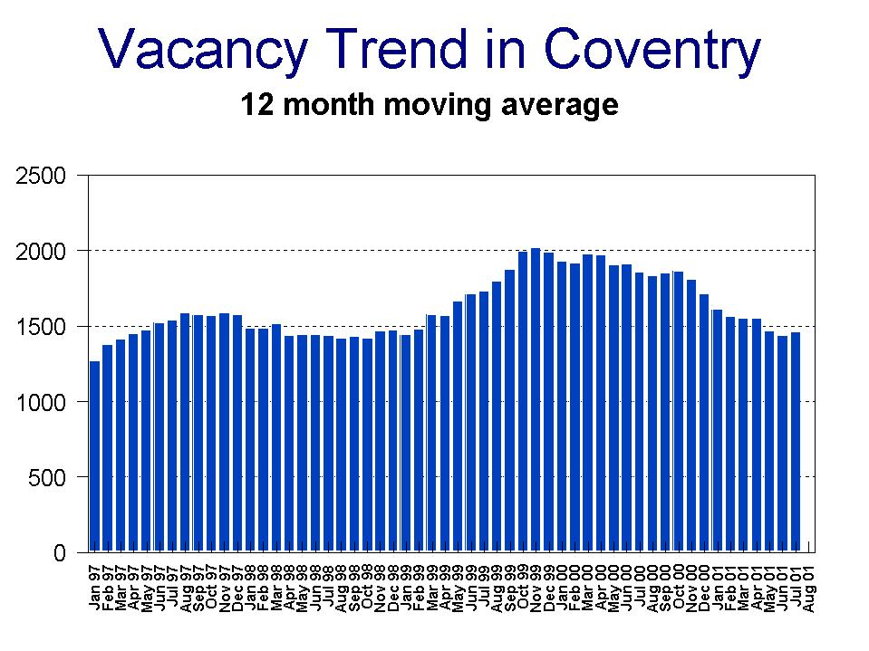

UNEMPLOYMENT FIGURES –AUGUST FIGURES

National unemployment has continued to fall despite the recession in the manufacturing industry. The service sector has been very buoyant over the summer and there have been more new jobs created in this sector than there have been jobs lost in manufacturing. The main factor has been the high level of consumer spending. Unemployment nationally, and for the city, remains at its lowest level since 1975. The national and regional figures show a 10% and 4.7% fall, respectively, on a year ago.

The West Midlands rates went up another point, to 3.8%, during August and the number of people unemployed exceeds 100,000. The fall in the last year was half the national average. This small rise may be attributed to the recession in the manufacturing industry. Significant jobs losses have occurred in the Black Country and Stoke on Trent.

 | Number of Claimants |  |  | Rate of Unemployment *
 | August 2001 | July 2001 | August 2000 | August 2001 | July 2001 | August 2000
UK | 945,600 | 952,373 | 1,051,300 | 3.1 | 3.2% | 3.6
West Midlands | 100,385 | 98,116 | 105,400 | 3.8 | 3.7% | 4.1
Coventry | 5,802 | 5,767 | 6,473 | 3.7 | 3.6% | 4.2

* Official rate, the claimant count as a percentage of the total workforce in the area. UK and West Midlands rates are seasonally adjusted. Coventry's data is not, but any seasonal factors are very small.

Unemployment in Coventry has fallen by 10.4% over the last year. It would seem that, during March and April, there were a series of jobs losses at Via Systems, Lotus, IMI Norgren and Marconi. During early spring, 500 jobs were lost over and above the number expected. This illustrates the vulnerability of the economy to a sharp downturn or major stream of redundancies. Fortunately, the high level of investment in the local economy has been creating jobs in many sectors. This has enabled the city’s economy to grow faster than that of the region.
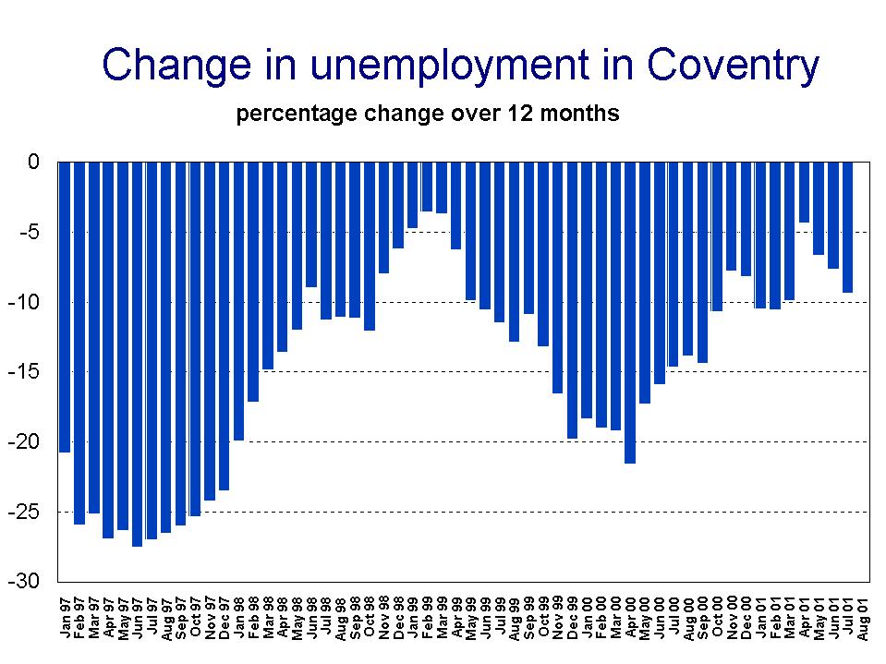

WARD DATA - AUGUST

During August, half the wards in Coventry suffered small rises in unemployment. Nearly all of these small rises may be explained by seasonal factors such as holidays, special events, etc. It is for this reason that year-on-year comparisons are better. Only two wards have witnessed rises in unemployment – Lower Stoke up by 24, and St. Michaels – up by 12. The largest falls have occurred in Longford and Henley – both down by over 95 in the last 12 months.

Only St. Michael's ward has unemployment outside the Community Plan target of 10%, although pockets of unemployment around the city can reach well over 25%. Unemployment figures in St. Michael's, Foleshill and Longford may be influenced by an influx of people, the shakeout of smaller manufacturing companies or measurement errors - or all three. Work over a longer term is being undertaken to identify the causes.

Coventry Ward Data |  |  |  |  |  |  |  | Unemployment by  Gender – August 2001
Ward | Aug.  2001 | July  2001 | Aug.  2000 | Aug.  2001 | July  2001 | Aug.  2000 |  | Male |  | Female
Ward | Total  Unemployed |  |  | Percentage Rate of Unemployment ** |  |  |  | Total | % | Total | %
Bablake | 136 | 129 | 156 | 2.1 | 2.0 | 2.4 |  | 97 | 2.6 | 39 | 1.3
Binley & Willenhall | 419 | 407 | 471 | 5.3 | 5.2 | 6.0 |  | 325 | 7.2 | 94 | 2.8
Cheylesmore | 173 | 184 | 198 | 2.7 | 2.8 | 3.0 |  | 144 | 3.9 | 29 | 1.0
Earlsdon | 177 | 177 | 208 | 2.5 | 2.5 | 3.0 |  | 126 | 3.2 | 51 | 1.6
Foleshill | 627 | 632 | 630 | 9.8 | 9.9 | 9.9 |  | 489 | 12.6 | 138 | 5.5
Henley | 371 | 390 | 466 | 4.8 | 5.1 | 6.1 |  | 285 | 6.7 | 86 | 2.5
Holbrooks | 321 | 330 | 348 | 4.0 | 4.1 | 4.3 |  | 236 | 5.2 | 85 | 2.5
Longford | 441 | 470 | 538 | 6.0 | 6.4 | 7.4 |  | 348 | 8.3 | 93 | 3.0
Lower Stoke | 334 | 320 | 311 | 5.0 | 4.8 | 4.6 |  | 261 | 6.8 | 73 | 2.6
Radford | 425 | 433 | 497 | 6.2 | 6.3 | 7.3 |  | 342 | 8.7 | 83 | 2.9
St. Michael’s | 713 | 682 | 701 | 12.6 | 12.1 | 12.4 |  | 552 | 16.0 | 161 | 7.3
Sherbourne | 262 | 266 | 314 | 3.6 | 3.6 | 4.3 |  | 197 | 4.7 | 65 | 2.1
Upper Stoke | 327 | 316 | 361 | 4.4 | 4.2 | 4.8 |  | 262 | 6.1 | 65 | 2.0
Wainbody | 77 | 71 | 97 | 1.4 | 1.3 | 1.8 |  | 54 | 1.7 | 23 | 0.9
Westwood | 277 | 268 | 327 | 4.8 | 4.7 | 5.7 |  | 214 | 6.4 | 63 | 2.6
Whoberley | 211 | 197 | 251 | 2.7 | 2.6 | 3.3 |  | 151 | 3.6 | 60 | 1.7
Woodlands | 260 | 241 | 312 | 2.9 | 2.7 | 3.5 |  | 201 | 4.0 | 59 | 1.5
Wyken | 251 | 254 | 287 | 3.0 | 3.0 | 3.4 |  | 189 | 4.0 | 62 | 1.7
Total Coventry | 5,802 | 5,767 | 6,473 | 4.5 | 4.5 | 5.1 |  | 4,473 | 6.1 | 1,329 | 2.4

** Resident based rate, the claimant count as a percentage of working age residents.

City Development Directorate
Research and Strategy
Regeneration Services
Civic Centre 4
Much Park Street
Coventry
CV1 2PY
1234567

